Temple Inn & Suites Web Site

# Purpose

The purpose of this site will be the following will be offer information about the Temple Inn & Suites hotels to people who search for accommodations near temples of The Church of Jesus Christ of Latter-Day Saints in the cities of Washington, DC, Houston, TX, Atlanta, GA, and Dallas, TX. The site will provide information about amenities and services offered by the hotels to guests. Visitors of the site will be able to books rooms and schedule service from a page on the web site. All properties are within a short walking distance from the temples.

# Target Audience

The target audience will be members of The Church of Jesus Christ of Latter-Day Saints who are traveling to worship at the church’s temples in the four cities mentioned above. Also, the hotel provides space and services for wedding receptions and it is expected that local church member will make use of that service.

## Scenarios

* Stephen and Laura and middle-aged visitors of the Washington D.C. Temple. They are driving all day to get to the temple and would like to stay for two nights. They do not have young children traveling with them. Laura is very interested in being able to use the hotel’s family history services and print ordinance cards to take to the temple.
* Samuel and Betsy are seniors serving a temple mission in Atlanta. They would like to stay long-term in a suite with a kitchenette that is close to the temple.
* Ricky and Maria and young millennials living in Houston who want to get married in the Houston Texas Temple. They wish to make use of the reception hall the evening after they are married.
* Marnie is a single mother of two young children. She is traveling to Dallas to visit the temple and needs child care while she is at the temple. On her way home, she wishes to change her clothes to be more comfortable while traveling.

# Site Map

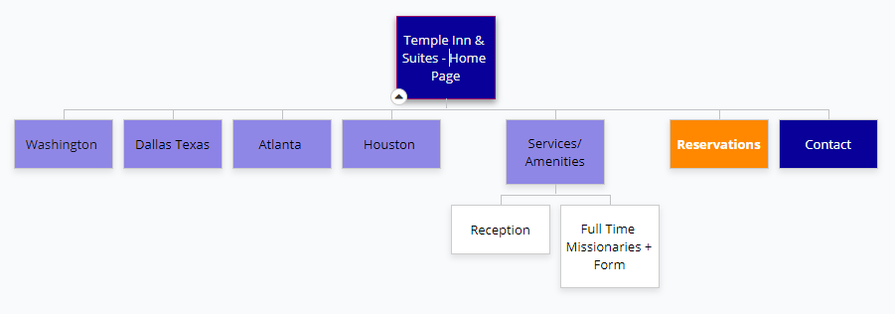

# Typography

## Site Title:

Playfair Display 50px

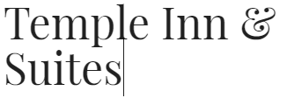

## Headings:

Archivo Narrow (bold)

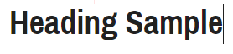

## Main and other copy:

Archivo



# Color Scheme

Call to action:

**Page Title**

Header:

Call to Action

Main copy:

Alt:

Navigation Bar:

# Wireframe Workups

Small Viewport (Phone)

A screenshot of a cell phone

Description generated with very high confidence

Medium view (notepad)

A screenshot of a cell phone

Description generated with high confidence

Large viewport (desktop)

A screenshot of a cell phone

Description generated with high confidence